Menaka 13/12/2023

How to visualize the content of the Data in easy understandable way in the excel and more visual representable way in Tableau

Data Visualization using Excel and Tableau

[Document subtitle]

1.Top 20 Ranked Countries GDP information 2

2.The chart for the whole country GDP information 3

3.Chart for the Top Ranked Countries chart and its macro buttons (Copy,Save,Delete) 4

4.All Countries GDP Information and its chart 6

5.TableauTop 20 Ranked countries GDP chart 10

6.Top 20 Ranked Countries Life Expectancy at birth Info Chart in Tableau 11

7.Top 20 Ranked Countries smartphone users Chart 12

8.Top 20 Ranked Countries Life Expectancy and SmartPhone Uers Chart 12

# 1.Top 20 Ranked Countries GDP information

The word of nation worksheet has been password protected and third column to be displayed in £ symbol and whole GDP data to be converted into the table in order to convert into the easily appealing visual way of displaying data in the form of chart.

Next, created the top 20 highest ranking countries from the table and appealing chart is displayed from table with following Details

1. Title is added
2. Labelled X and y axis
3. Make the chart visually pleasing

|  |  |  |  |
| --- | --- | --- | --- |
| **Rank** | **Country** | **GDP - per capita (PPP)** | **Year of Information** |
| 1 | Monaco | $190,513.00 | 2019 |
| 3 | Macau | $123,965.00 | 2019 |
| 5 | Singapore | $97,341.00 | 2019 |
| 6 | Qatar | $90,044.00 | 2019 |
| 7 | Ireland | $86,781.00 | 2019 |
| 9 | Bermuda | $81,798.00 | 2019 |
| 12 | Switzerland | $68,628.00 | 2019 |
| 13 | United Arab Emirates | $67,119.00 | 2019 |
| 14 | Norway | $63,633.00 | 2019 |
| 15 | United States | $62,530.00 | 2019 |
| 16 | Brunei | $62,100.00 | 2019 |
| 18 | Hong Kong | $59,848.00 | 2019 |
| 20 | Denmark | $57,804.00 | 2019 |
|  |  |  |  |
|  |  |  |  |
| |  | | --- | |  | |  |  |  |
|  |  |  |  |
|  |  |  |  |
|  |  |  |  |
|  |  |  |  |
|  |  |  |  |
|  |  |  |  |
|  |  |  |  |
|  |  |  |  |
|  |  |  |  |
|  |  |  |  |
|  |  |  |  |
|  |  |  |  |
|  |  |  |  |
|  |  |  |  |
|  |  |  |  |
|  |  |  |  |
|  |  |  |  |

# 2.The chart for the whole country GDP information

The word of nation worksheet has been password protected and third column to be displayed in £ symbol and whole GDP data to be converted into the table in order to convert into the easily appealing visual way of displaying data in the form of chart.

Next, appealing chart for all the countries and its rank with GDP details is displayed from table with following Details

1. Added Title
2. Labelled X and y axis
3. Make the chart visually pleasing

# 3.Chart for the Top Ranked Countries chart and its macro buttons (Copy,Save,Delete)

The Top 20 high ranked Countries details with Chart is displayed with the three Macro buttons for doing the following Actions

* Copy
* Print
* Save

|  |  |  |  |
| --- | --- | --- | --- |
| **Rank** | **Country** | **GDP - per capita (PPP)** | **Year of Information** |
| 1 | Monaco | $190,513.00 | 2019 |
| 3 | Macau | $123,965.00 | 2019 |
| 5 | Singapore | $97,341.00 | 2019 |
| 6 | Qatar | $90,044.00 | 2019 |
| 7 | Ireland | $86,781.00 | 2019 |
| 9 | Bermuda | $81,798.00 | 2019 |
| 12 | Switzerland | $68,628.00 | 2019 |
| 13 | United Arab Emirates | $67,119.00 | 2019 |
| 14 | Norway | $63,633.00 | 2019 |
| 15 | United States | $62,530.00 | 2019 |
| 16 | Brunei | $62,100.00 | 2019 |
| 18 | Hong Kong | $59,848.00 | 2019 |
| 20 | Denmark | $57,804.00 | 2019 |
|  |  |  |  |
|  |  |  |  |
| |  | | --- | |  | |  |  |  |
|  |  |  |  |
|  |  |  |  |
|  |  |  |  |
|  |  |  |  |
|  |  |  |  |
|  |  |  |  |
|  |  |  |  |
|  |  |  |  |
|  |  |  |  |
|  |  |  |  |
|  |  |  |  |
|  |  |  |  |
|  |  |  |  |
|  |  |  |  |
|  |  |  |  |
|  |  |  |  |
| |  | | --- | |  | |  |  |  |
|  |  |  |  |
|  |  |  |  |
| print |  |  |  |
|  | copy |  |  |

# 4.All Countries GDP Information and its chart

The word of nation worksheet has been password protected and third column to be displayed in £ symbol and whole GDP data to be converted into the table in order to convert into the easily appealing visual way of displaying data in the form of chart.

Next, appealing chart for all the countries and its rank with GDP details is displayed from table with following Details

1. Added Title
2. Labelled X and y axis
3. Make the chart visually pleasing

|  |  |  |  |  |  |  |  |  |  |  |  |  |  |  |  |  |  |  |  |
| --- | --- | --- | --- | --- | --- | --- | --- | --- | --- | --- | --- | --- | --- | --- | --- | --- | --- | --- | --- |
| **Rank** | **Country** | **GDP - per capita (PPP)** | **Year of Information** |  |  |  |  |  |  |  |  |  |  |  |  |  |  |  |  |
| 1 | Monaco | $190,513.00 | 2019 |  |  |  |  |  |  |  |  |  |  |  |  |  |  |  |  |
| 3 | Macau | $123,965.00 | 2019 |  |  |  |  |  |  |  |  |  |  |  |  |  |  |  |  |
| 5 | Singapore | $97,341.00 | 2019 |  |  |  |  |  |  |  |  |  |  |  |  |  |  |  |  |
| 6 | Qatar | $90,044.00 | 2019 |  |  |  |  |  |  |  |  |  |  |  |  |  |  |  |  |
| 7 | Ireland | $86,781.00 | 2019 |  |  |  |  |  |  |  |  |  |  |  |  |  |  |  |  |
| 9 | Bermuda | $81,798.00 | 2019 |  |  |  |  |  |  |  |  |  |  |  |  |  |  |  |  |
| 12 | Switzerland | $68,628.00 | 2019 |  |  |  |  |  |  |  |  |  |  |  |  |  |  |  |  |
| 13 | United Arab Emirates | $67,119.00 | 2019 |  |  |  |  |  |  |  |  |  |  |  |  |  |  |  |  |
| 14 | Norway | $63,633.00 | 2019 |  |  |  |  |  |  |  |  |  |  |  |  |  |  |  |  |
| 15 | United States | $62,530.00 | 2019 |  |  |  |  |  |  |  |  |  |  |  |  |  |  |  |  |
| 16 | Brunei | $62,100.00 | 2019 |  |  |  |  |  |  |  |  |  |  |  |  |  |  |  |  |
| 18 | Hong Kong | $59,848.00 | 2019 |  |  |  |  |  |  |  |  |  |  |  |  |  |  |  |  |
| 20 | Denmark | $57,804.00 | 2019 |  |  |  |  |  |  |  |  |  |  |  |  |  |  |  |  |
| 21 | Netherlands | $56,935.00 | 2019 |  |  |  |  |  |  |  |  |  |  |  |  |  |  |  |  |
| 23 | Austria | $56,188.00 | 2019 |  |  |  |  |  |  |  |  |  |  |  |  |  |  |  |  |
| 24 | Iceland | $55,874.00 | 2019 |  |  |  |  |  |  |  |  |  |  |  |  |  |  |  |  |
| 25 | Germany | $53,919.00 | 2019 |  |  |  |  |  |  |  |  |  |  |  |  |  |  |  |  |
| 26 | Sweden | $53,240.00 | 2019 |  |  |  |  |  |  |  |  |  |  |  |  |  |  |  |  |
| 28 | Belgium | $51,934.00 | 2019 |  |  |  |  |  |  |  |  |  |  |  |  |  |  |  |  |
| 31 | Australia | $49,854.00 | 2019 |  |  |  |  |  |  |  |  |  |  |  |  |  |  |  |  |
| 32 | Kuwait | $49,854.00 | 2019 |  |  |  |  |  |  |  |  |  |  |  |  |  |  |  |  |
| 33 | Canada | $49,031.00 | 2019 |  |  |  |  |  |  |  |  |  |  |  |  |  |  |  |  |
| 34 | Finland | $48,668.00 | 2019 |  |  |  |  |  |  |  |  |  |  |  |  |  |  |  |  |
| 35 | Saudi Arabia | $46,962.00 | 2019 |  |  |  |  |  |  |  |  |  |  |  |  |  |  |  |  |
| 36 | United Kingdom | $46,659.00 | 2019 |  |  |  |  |  |  |  |  |  |  |  |  |  |  |  |  |
| 38 | France | $46,184.00 | 2019 |  |  |  |  |  |  |  |  |  |  |  |  |  |  |  |  |
| 39 | Bahrain | $45,011.00 | 2019 |  |  |  |  |  |  |  |  |  |  |  |  |  |  |  |  |
| 40 | EU | $44,436.00 | 2019 |  |  |  |  |  |  |  |  |  |  |  |  |  |  |  |  |
| 41 | Malta | $44,032.00 | 2019 |  |  |  |  |  |  |  |  |  |  |  |  |  |  |  |  |
| 42 | New Zealand | $42,888.00 | 2019 |  |  |  |  |  |  |  |  |  |  |  |  |  |  |  |  |
| 43 | South Korea | $42,765.00 | 2019 |  |  |  |  |  |  |  |  |  |  |  |  |  |  |  |  |
| 44 | Italy | $42,492.00 | 2019 |  |  |  |  |  |  |  |  |  |  |  |  |  |  |  |  |
| 46 | Japan | $41,429.00 | 2019 |  |  |  |  |  |  |  |  |  |  |  |  |  |  |  |  |
| 47 | Spain | $40,903.00 | 2019 |  |  |  |  |  |  |  |  |  |  |  |  |  |  |  |  |
| 48 | Czech Republic | $40,862.00 | 2019 |  |  |  |  |  |  |  |  |  |  |  |  |  |  |  |  |
| 49 | Israel | $40,145.00 | 2019 |  |  |  |  |  |  |  |  |  |  |  |  |  |  |  |  |
| 51 | Cyprus | $39,545.00 | 2019 |  |  |  |  |  |  |  |  |  |  |  |  |  |  |  |  |
| 52 | Slovenia | $39,088.00 | 2019 |  |  |  |  |  |  |  |  |  |  |  |  |  |  |  |  |
| 54 | Lithuania | $37,231.00 | 2019 |  |  |  |  |  |  |  |  |  |  |  |  |  |  |  |  |
| 55 | Bahamas | $37,101.00 | 2019 |  |  |  |  |  |  |  |  |  |  |  |  |  |  |  |  |
| 57 | Estonia | $36,927.00 | 2019 |  |  |  |  |  |  |  |  |  |  |  |  |  |  |  |  |
| 60 | Portugal | $34,894.00 | 2019 |  |  |  |  |  |  |  |  |  |  |  |  |  |  |  |  |
| 61 | Puerto Rico | $34,518.00 | 2019 |  |  |  |  |  |  |  |  |  |  |  |  |  |  |  |  |
| 63 | Poland | $33,221.00 | 2019 |  |  |  |  |  |  |  |  |  |  |  |  |  |  |  |  |
| 64 | Hungary | $32,945.00 | 2019 |  |  |  |  |  |  |  |  |  |  |  |  |  |  |  |  |
| 65 | Slovakia | $32,730.00 | 2019 |  |  |  |  |  |  |  |  |  |  |  |  |  |  |  |  |
| 66 | Panama | $31,459.00 | 2019 |  |  |  |  |  |  |  |  |  |  |  |  |  |  |  |  |
| 68 | Latvia | $30,898.00 | 2019 |  |  |  |  |  |  |  |  |  |  |  |  |  |  |  |  |
| 69 | Romania | $29,941.00 | 2019 |  |  |  |  |  |  |  |  |  |  |  |  |  |  |  |  |
| 70 | Greece | $29,799.00 | 2019 |  |  |  |  |  |  |  |  |  |  |  |  |  |  |  |  |
| 71 | Turks and Caicos Islands | $29,253.00 | 2019 |  |  |  |  |  |  |  |  |  |  |  |  |  |  |  |  |
| 72 | Seychelles | $29,223.00 | 2019 |  |  |  |  |  |  |  |  |  |  |  |  |  |  |  |  |
| 73 | Croatia | $28,602.00 | 2019 |  |  |  |  |  |  |  |  |  |  |  |  |  |  |  |  |
| 74 | Turkey | $28,424.00 | 2019 |  |  |  |  |  |  |  |  |  |  |  |  |  |  |  |  |
| 75 | Malaysia | $28,364.00 | 2019 |  |  |  |  |  |  |  |  |  |  |  |  |  |  |  |  |
| 76 | Oman | $27,299.00 | 2019 |  |  |  |  |  |  |  |  |  |  |  |  |  |  |  |  |
| 77 | Russia | $27,044.00 | 2019 |  |  |  |  |  |  |  |  |  |  |  |  |  |  |  |  |
| 78 | Saint Kitts and Nevis | $26,438.00 | 2019 |  |  |  |  |  |  |  |  |  |  |  |  |  |  |  |  |
| 79 | Kazakhstan | $26,351.00 | 2019 |  |  |  |  |  |  |  |  |  |  |  |  |  |  |  |  |
| 80 | Trinidad and Tobago | $26,176.00 | 2019 |  |  |  |  |  |  |  |  |  |  |  |  |  |  |  |  |
| 82 | Curaçao | $24,479.00 | 2019 |  |  |  |  |  |  |  |  |  |  |  |  |  |  |  |  |
| 83 | Chile | $24,226.00 | 2019 |  |  |  |  |  |  |  |  |  |  |  |  |  |  |  |  |
| 84 | Bulgaria | $23,174.00 | 2019 |  |  |  |  |  |  |  |  |  |  |  |  |  |  |  |  |
| 85 | Mauritius | $22,870.00 | 2019 |  |  |  |  |  |  |  |  |  |  |  |  |  |  |  |  |
| 86 | Argentina | $22,064.00 | 2019 |  |  |  |  |  |  |  |  |  |  |  |  |  |  |  |  |
| 87 | Antigua and Barbuda | $21,910.00 | 2019 |  |  |  |  |  |  |  |  |  |  |  |  |  |  |  |  |
| 88 | Uruguay | $21,561.00 | 2019 |  |  |  |  |  |  |  |  |  |  |  |  |  |  |  |  |
| 89 | Montenegro | $21,470.00 | 2019 |  |  |  |  |  |  |  |  |  |  |  |  |  |  |  |  |
| 90 | Mexico | $19,796.00 | 2019 |  |  |  |  |  |  |  |  |  |  |  |  |  |  |  |  |
| 91 | Costa Rica | $19,642.00 | 2019 |  |  |  |  |  |  |  |  |  |  |  |  |  |  |  |  |
| 92 | Maldives | $19,531.00 | 2019 |  |  |  |  |  |  |  |  |  |  |  |  |  |  |  |  |
| 94 | Belarus | $19,150.00 | 2019 |  |  |  |  |  |  |  |  |  |  |  |  |  |  |  |  |
| 95 | Equatorial Guinea | $18,558.00 | 2019 |  |  |  |  |  |  |  |  |  |  |  |  |  |  |  |  |
| 96 | Thailand | $18,460.00 | 2019 |  |  |  |  |  |  |  |  |  |  |  |  |  |  |  |  |
| 97 | Dominican Republic | $18,413.00 | 2019 |  |  |  |  |  |  |  |  |  |  |  |  |  |  |  |  |
| 98 | Serbia | $18,233.00 | 2019 |  |  |  |  |  |  |  |  |  |  |  |  |  |  |  |  |
| 99 | Botswana | $17,767.00 | 2019 |  |  |  |  |  |  |  |  |  |  |  |  |  |  |  |  |
| 100 | Palau | $17,579.00 | 2019 |  |  |  |  |  |  |  |  |  |  |  |  |  |  |  |  |
| 102 | Grenada | $17,039.00 | 2019 |  |  |  |  |  |  |  |  |  |  |  |  |  |  |  |  |
| 105 | Suriname | $16,525.00 | 2019 |  |  |  |  |  |  |  |  |  |  |  |  |  |  |  |  |
| 106 | North Macedonia | $16,479.00 | 2019 |  |  |  |  |  |  |  |  |  |  |  |  |  |  |  |  |
| 107 | China | $16,117.00 | 2019 |  |  |  |  |  |  |  |  |  |  |  |  |  |  |  |  |
| 108 | Barbados | $15,639.00 | 2019 |  |  |  |  |  |  |  |  |  |  |  |  |  |  |  |  |
| 109 | Saint Lucia | $15,449.00 | 2019 |  |  |  |  |  |  |  |  |  |  |  |  |  |  |  |  |
| 110 | Libya | $15,174.00 | 2019 |  |  |  |  |  |  |  |  |  |  |  |  |  |  |  |  |
| 111 | Georgia | $14,992.00 | 2019 |  |  |  |  |  |  |  |  |  |  |  |  |  |  |  |  |
| 112 | Gabon | $14,950.00 | 2019 |  |  |  |  |  |  |  |  |  |  |  |  |  |  |  |  |
| 113 | Bosnia and Herzegovina | $14,912.00 | 2019 |  |  |  |  |  |  |  |  |  |  |  |  |  |  |  |  |
| 115 | Colombia | $14,722.00 | 2019 |  |  |  |  |  |  |  |  |  |  |  |  |  |  |  |  |
| 116 | Brazil | $14,652.00 | 2019 |  |  |  |  |  |  |  |  |  |  |  |  |  |  |  |  |
| 117 | Lebanon | $14,552.00 | 2019 |  |  |  |  |  |  |  |  |  |  |  |  |  |  |  |  |
| 118 | Azerbaijan | $14,404.00 | 2019 |  |  |  |  |  |  |  |  |  |  |  |  |  |  |  |  |
| 119 | Albania | $13,965.00 | 2019 |  |  |  |  |  |  |  |  |  |  |  |  |  |  |  |  |
| 120 | Fiji | $13,684.00 | 2019 |  |  |  |  |  |  |  |  |  |  |  |  |  |  |  |  |
| 121 | Armenia | $13,654.00 | 2019 |  |  |  |  |  |  |  |  |  |  |  |  |  |  |  |  |
| 122 | Guyana | $13,082.00 | 2019 |  |  |  |  |  |  |  |  |  |  |  |  |  |  |  |  |
| 123 | Sri Lanka | $13,078.00 | 2019 |  |  |  |  |  |  |  |  |  |  |  |  |  |  |  |  |
| 124 | Moldova | $13,050.00 | 2019 |  |  |  |  |  |  |  |  |  |  |  |  |  |  |  |  |
| 125 | Peru | $12,848.00 | 2019 |  |  |  |  |  |  |  |  |  |  |  |  |  |  |  |  |
| 126 | Ukraine | $12,810.00 | 2019 |  |  |  |  |  |  |  |  |  |  |  |  |  |  |  |  |
| 127 | Paraguay | $12,685.00 | 2019 |  |  |  |  |  |  |  |  |  |  |  |  |  |  |  |  |
| 128 | Saint Vincent & the Grenadines | $12,485.00 | 2019 |  |  |  |  |  |  |  |  |  |  |  |  |  |  |  |  |
| 129 | South Africa | $12,482.00 | 2019 |  |  |  |  |  |  |  |  |  |  |  |  |  |  |  |  |
| 130 | Iran | $12,389.00 | 2019 |  |  |  |  |  |  |  |  |  |  |  |  |  |  |  |  |
| 131 | Mongolia | $12,317.00 | 2019 |  |  |  |  |  |  |  |  |  |  |  |  |  |  |  |  |
| 134 | Dominica | $11,917.00 | 2019 |  |  |  |  |  |  |  |  |  |  |  |  |  |  |  |  |
| 135 | Bhutan | $11,832.00 | 2019 |  |  |  |  |  |  |  |  |  |  |  |  |  |  |  |  |
| 136 | Indonesia | $11,812.00 | 2019 |  |  |  |  |  |  |  |  |  |  |  |  |  |  |  |  |
| 137 | Egypt | $11,763.00 | 2019 |  |  |  |  |  |  |  |  |  |  |  |  |  |  |  |  |
| 138 | Nauru | $11,583.00 | 2019 |  |  |  |  |  |  |  |  |  |  |  |  |  |  |  |  |
| 139 | Algeria | $11,511.00 | 2019 |  |  |  |  |  |  |  |  |  |  |  |  |  |  |  |  |
| 140 | Ecuador | $11,375.00 | 2019 |  |  |  |  |  |  |  |  |  |  |  |  |  |  |  |  |
| 141 | Kosovo | $11,368.00 | 2019 |  |  |  |  |  |  |  |  |  |  |  |  |  |  |  |  |
| 143 | Iraq | $10,881.00 | 2019 |  |  |  |  |  |  |  |  |  |  |  |  |  |  |  |  |
| 144 | Tunisia | $10,756.00 | 2019 |  |  |  |  |  |  |  |  |  |  |  |  |  |  |  |  |
| 145 | Jordan | $10,071.00 | 2019 |  |  |  |  |  |  |  |  |  |  |  |  |  |  |  |  |
| 146 | Jamaica | $9,762.00 | 2019 |  |  |  |  |  |  |  |  |  |  |  |  |  |  |  |  |
| 147 | Namibia | $9,637.00 | 2019 |  |  |  |  |  |  |  |  |  |  |  |  |  |  |  |  |
| 148 | Philippines | $8,908.00 | 2019 |  |  |  |  |  |  |  |  |  |  |  |  |  |  |  |  |
| 149 | El Salvador | $8,776.00 | 2019 |  |  |  |  |  |  |  |  |  |  |  |  |  |  |  |  |
| 150 | Bolivia | $8,724.00 | 2019 |  |  |  |  |  |  |  |  |  |  |  |  |  |  |  |  |
| 151 | Guatemala | $8,637.00 | 2019 |  |  |  |  |  |  |  |  |  |  |  |  |  |  |  |  |
| 152 | Eswatini | $8,622.00 | 2019 |  |  |  |  |  |  |  |  |  |  |  |  |  |  |  |  |
| 153 | Vietnam | $8,041.00 | 2019 |  |  |  |  |  |  |  |  |  |  |  |  |  |  |  |  |
| 154 | Laos | $7,826.00 | 2019 |  |  |  |  |  |  |  |  |  |  |  |  |  |  |  |  |
| 156 | Morocco | $7,515.00 | 2019 |  |  |  |  |  |  |  |  |  |  |  |  |  |  |  |  |
| 157 | Cape Verde | $7,172.00 | 2019 |  |  |  |  |  |  |  |  |  |  |  |  |  |  |  |  |
| 158 | Belize | $7,005.00 | 2019 |  |  |  |  |  |  |  |  |  |  |  |  |  |  |  |  |
| 159 | Uzbekistan | $6,999.00 | 2019 |  |  |  |  |  |  |  |  |  |  |  |  |  |  |  |  |
| 160 | India | $6,700.00 | 2019 |  |  |  |  |  |  |  |  |  |  |  |  |  |  |  |  |
| 161 | Angola | $6,670.00 | 2019 |  |  |  |  |  |  |  |  |  |  |  |  |  |  |  |  |
| 162 | Samoa | $6,521.00 | 2019 |  |  |  |  |  |  |  |  |  |  |  |  |  |  |  |  |
| 163 | Tonga | $6,383.00 | 2019 |  |  |  |  |  |  |  |  |  |  |  |  |  |  |  |  |
| 164 | Palestine | $6,220.00 | 2019 |  |  |  |  |  |  |  |  |  |  |  |  |  |  |  |  |
| 167 | Honduras | $5,728.00 | 2019 |  |  |  |  |  |  |  |  |  |  |  |  |  |  |  |  |
| 168 | Djibouti | $5,535.00 | 2019 |  |  |  |  |  |  |  |  |  |  |  |  |  |  |  |  |
| 169 | Ghana | $5,413.00 | 2019 |  |  |  |  |  |  |  |  |  |  |  |  |  |  |  |  |
| 170 | Nicaragua | $5,407.00 | 2019 |  |  |  |  |  |  |  |  |  |  |  |  |  |  |  |  |
| 171 | Kyrgyzstan | $5,253.00 | 2019 |  |  |  |  |  |  |  |  |  |  |  |  |  |  |  |  |
| 172 | Ivory Coast | $5,213.00 | 2019 |  |  |  |  |  |  |  |  |  |  |  |  |  |  |  |  |
| 173 | Mauritania | $5,197.00 | 2019 |  |  |  |  |  |  |  |  |  |  |  |  |  |  |  |  |
| 174 | Myanmar | $5,142.00 | 2019 |  |  |  |  |  |  |  |  |  |  |  |  |  |  |  |  |
| 175 | Nigeria | $5,136.00 | 2019 |  |  |  |  |  |  |  |  |  |  |  |  |  |  |  |  |
| 176 | Bangladesh | $4,754.00 | 2019 |  |  |  |  |  |  |  |  |  |  |  |  |  |  |  |  |
| 177 | Pakistan | $4,690.00 | 2019 |  |  |  |  |  |  |  |  |  |  |  |  |  |  |  |  |
| 178 | Cambodia | $4,389.00 | 2019 |  |  |  |  |  |  |  |  |  |  |  |  |  |  |  |  |
| 179 | Papua New Guinea | $4,355.00 | 2019 |  |  |  |  |  |  |  |  |  |  |  |  |  |  |  |  |
| 180 | Kenya | $4,330.00 | 2019 |  |  |  |  |  |  |  |  |  |  |  |  |  |  |  |  |
| 181 | Tuvalu | $4,281.00 | 2019 |  |  |  |  |  |  |  |  |  |  |  |  |  |  |  |  |
| 182 | São Tomé and Príncipe | $3,970.00 | 2019 |  |  |  |  |  |  |  |  |  |  |  |  |  |  |  |  |
| 183 | Sudan | $3,958.00 | 2019 |  |  |  |  |  |  |  |  |  |  |  |  |  |  |  |  |
| 186 | Congo | $3,673.00 | 2019 |  |  |  |  |  |  |  |  |  |  |  |  |  |  |  |  |
| 187 | Cameroon | $3,642.00 | 2019 |  |  |  |  |  |  |  |  |  |  |  |  |  |  |  |  |
| 188 | East Timor | $3,553.00 | 2019 |  |  |  |  |  |  |  |  |  |  |  |  |  |  |  |  |
| 189 | Zambia | $3,470.00 | 2019 |  |  |  |  |  |  |  |  |  |  |  |  |  |  |  |  |
| 191 | Nepal | $3,417.00 | 2019 |  |  |  |  |  |  |  |  |  |  |  |  |  |  |  |  |
| 192 | Senegal | $3,395.00 | 2019 |  |  |  |  |  |  |  |  |  |  |  |  |  |  |  |  |
| 193 | Tajikistan | $3,380.00 | 2019 |  |  |  |  |  |  |  |  |  |  |  |  |  |  |  |  |
| 194 | Benin | $3,287.00 | 2019 |  |  |  |  |  |  |  |  |  |  |  |  |  |  |  |  |
| 195 | Vanuatu | $3,153.00 | 2019 |  |  |  |  |  |  |  |  |  |  |  |  |  |  |  |  |
| 196 | Comoros | $3,060.00 | 2019 |  |  |  |  |  |  |  |  |  |  |  |  |  |  |  |  |
| 197 | Haiti | $2,905.00 | 2019 |  |  |  |  |  |  |  |  |  |  |  |  |  |  |  |  |
| 199 | Zimbabwe | $2,836.00 | 2019 |  |  |  |  |  |  |  |  |  |  |  |  |  |  |  |  |
| 200 | Lesotho | $2,704.00 | 2019 |  |  |  |  |  |  |  |  |  |  |  |  |  |  |  |  |
| 201 | Solomon Islands | $2,663.00 | 2019 |  |  |  |  |  |  |  |  |  |  |  |  |  |  |  |  |
| 202 | Tanzania | $2,660.00 | 2019 |  |  |  |  |  |  |  |  |  |  |  |  |  |  |  |  |
| 203 | Guinea | $2,562.00 | 2019 |  |  |  |  |  |  |  |  |  |  |  |  |  |  |  |  |
| 205 | Mali | $2,322.00 | 2019 |  |  |  |  |  |  |  |  |  |  |  |  |  |  |  |  |
| 206 | Kiribati | $2,272.00 | 2019 |  |  |  |  |  |  |  |  |  |  |  |  |  |  |  |  |
| 207 | Rwanda | $2,227.00 | 2019 |  |  |  |  |  |  |  |  |  |  |  |  |  |  |  |  |
| 208 | Gambia | $2,223.00 | 2019 |  |  |  |  |  |  |  |  |  |  |  |  |  |  |  |  |
| 209 | Ethiopia | $2,221.00 | 2019 |  |  |  |  |  |  |  |  |  |  |  |  |  |  |  |  |
| 210 | Uganda | $2,187.00 | 2019 |  |  |  |  |  |  |  |  |  |  |  |  |  |  |  |  |
| 211 | Burkina Faso | $2,178.00 | 2019 |  |  |  |  |  |  |  |  |  |  |  |  |  |  |  |  |
| 212 | Afghanistan | $2,065.00 | 2019 |  |  |  |  |  |  |  |  |  |  |  |  |  |  |  |  |
| 213 | Guinea-Bissau | $1,989.00 | 2019 |  |  |  |  |  |  |  |  |  |  |  |  |  |  |  |  |
| 214 | Sierra Leone | $1,718.00 | 2019 |  |  |  |  |  |  |  |  |  |  |  |  |  |  |  |  |
| 216 | Madagascar | $1,647.00 | 2019 |  |  |  |  |  |  |  |  |  |  |  |  |  |  |  |  |
| 217 | Eritrea | $1,600.00 | 2019 |  |  |  |  |  |  |  |  |  |  |  |  |  |  |  |  |
| 219 | Togo | $1,597.00 | 2019 |  |  |  |  |  |  |  |  |  |  |  |  |  |  |  |  |
| 220 | Chad | $1,580.00 | 2019 |  |  |  |  |  |  |  |  |  |  |  |  |  |  |  |  |
| 221 | Liberia | $1,428.00 | 2019 |  |  |  |  |  |  |  |  |  |  |  |  |  |  |  |  |
| 222 | Mozambique | $1,281.00 | 2019 |  |  |  |  |  |  |  |  |  |  |  |  |  |  |  |  |
| 223 | Niger | $1,225.00 | 2019 |  |  |  |  |  |  |  |  |  |  |  |  |  |  |  |  |
| 224 | DR Congo | $1,098.00 | 2019 |  |  |  |  |  |  |  |  |  |  |  |  |  |  |  |  |
| 225 | Malawi | $1,060.00 | 2019 |  |  |  |  |  |  |  |  |  |  |  |  |  |  |  |  |
| 226 | Central African Republic | $945.00 | 2019 |  |  |  |  |  |  |  |  |  |  |  |  |  |  |  |  |
| 228 | Burundi | $752.00 | 2019 |  |  |  |  |  |  |  |  |  |  |  |  |  |  |  |  |

# 5.**Tableau Top 20 Ranked countries GDP chart**

The relationship has been set up in the following sheets in the Tableau

* GDP
* Life Expectancy
* SmartPhone

And Top 20 high ranked countries from GDP Table has been created with calculated Field in order to create the bar chart with following details

* + - Title added
    - Added X and Y axis labels
    - Make the chart visually pleasing

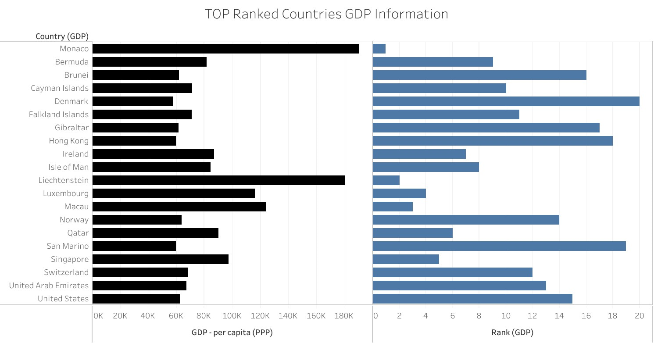

# **6.Top 20 Ranked Countries Life Expectancy at birth Info Chart in Tableau**

Top 20 high ranked countries from Life Expectancy table has been created with calculated Field in order to create the bar chart with following details

* Top 20 High Ranked Countries and its Rank in X axis
* Life Expectancy at birth in Y axis

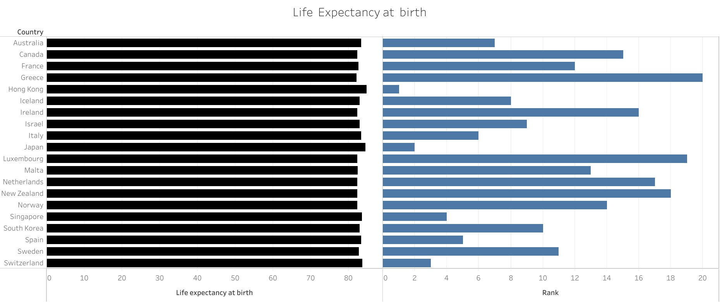

# **7.Top 20 Ranked Countries smartphone users Chart**

Top 20 high ranked countries from SmartPhoneUsers table has been created with calculated Field in order to create the bar chart with following details

* Top 20 High Ranked Countries and its Rank in X axis
* Avearge of SmartPhoneusers in Y axis

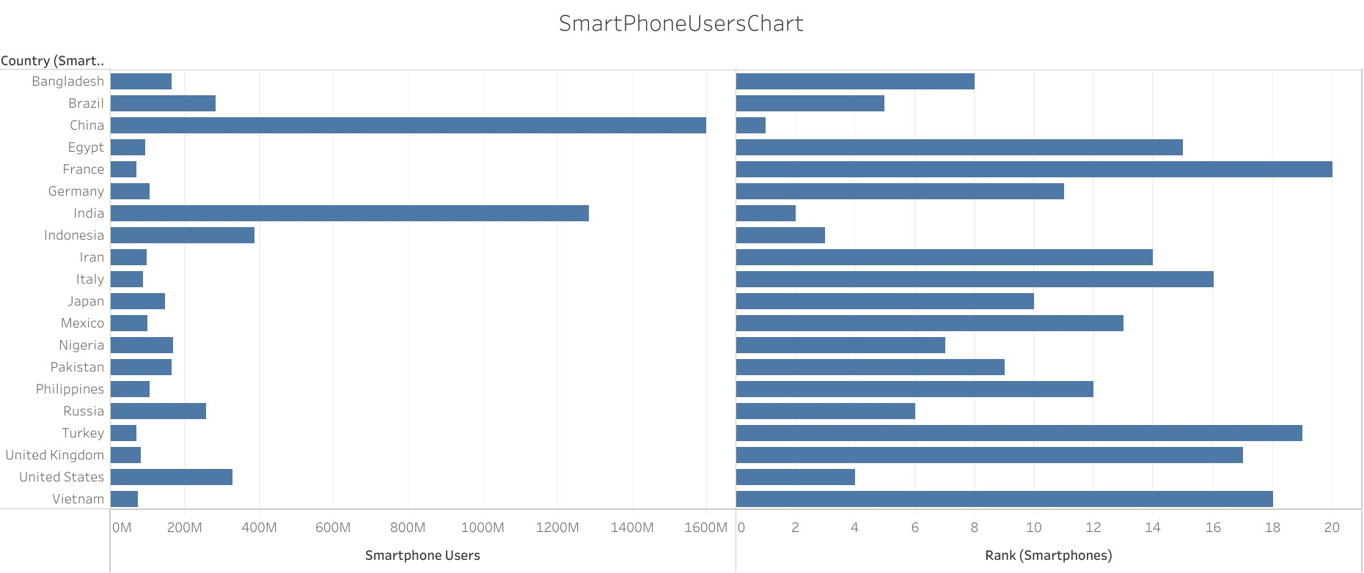

# 8.Top 20 Ranked Countries Life Expectancy and SmartPhone Uers Chart

Top 20 high ranked countries crated from the combination of the three tables SmartPhoneUsers and life expectancy has been created with calculated Field from GDP table in order to create the bar chart with following details

* Top 20 High Ranked Countries and its Rank in X axis
* Avearge of SmartPhoneusers and life expectancy at birth in Y axis

